SALARY SURVEY ANALYSIS - 2021

**Objective:**

The objective of this project is to analyse salary survey data from 2021 to identify trends, disparities, and insights regarding compensation across different industries , job roles ,Experience level and location.

The analysis aims to provide valuable insights for employees and employers to understand salary structures and potential inequalities.

**DATASET DISCRIPTION:**

The dataset used for this analysis includes salary data collected from multiple sources, including online salary surveys, job postings, and reports from HR agencies. The dataset contains the following attributes:

**Job Title**

* The designation of employees.

**Industry**

* The sector in which the employee works.

**Years of Experience**

* Work experience in years.

**Region**

* Geographical location of the employee.

**Annual Salary**

* Compensation in local currency.

**Education Level**

* Highest qualification attained.

**STEPS INVOLVED IN THE ANALYSIS**

**Step1: Data Cleaning and Preprocessing**

* Cleaned the raw data with contains 27000 rows.
* Cleaned the dataset by handling missing values and inconsistencies.
* Removing outliers and normalizing salary values.
* Standardized salary figures across different currencies for consistency.

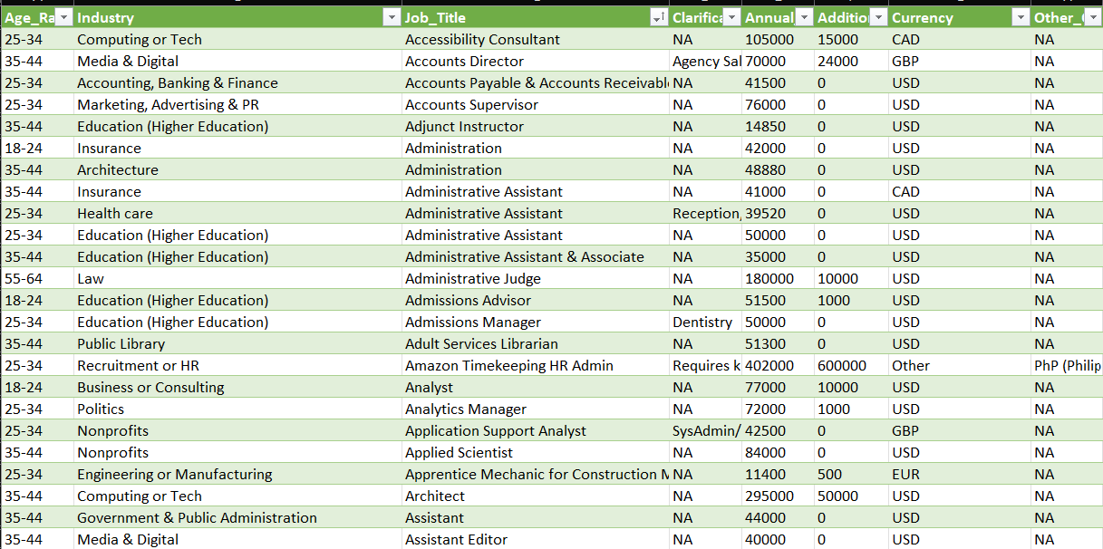

**Step 2: Exploratory Data Analysis (EDA)**

* Exported cleaned data to SQL by changing the dataset into CSV file.
* The dataset was the extracted then entered the queries for the given question. Then fetched the result from the dataset.

**1. Average Salary by Industry and Gender**

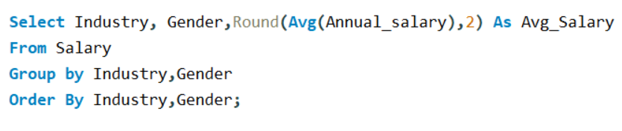

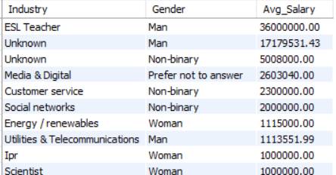

**2. Total Salary Compensation by Job Title.**

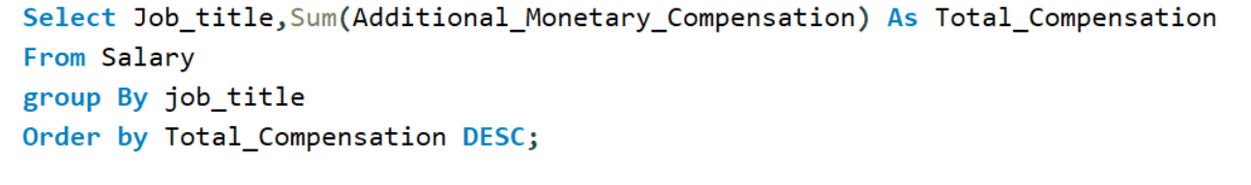

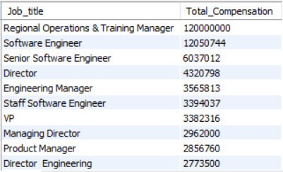

**3.Job Titles with the Highest Salary in Each Country**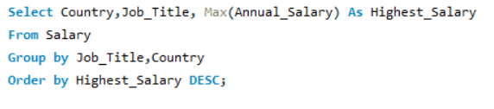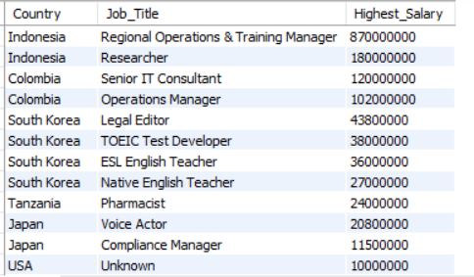

**Step 3: DATA MODELING**

* After exporting, the tables were collected in single workbook.
* Added tables to data model in Power Pivot.
* Created relations(connections) across Tables.

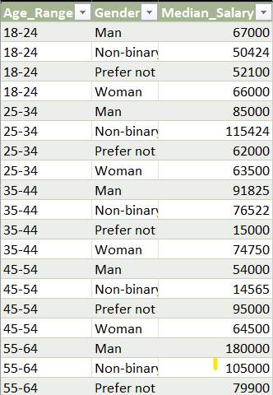

**Step4: Power Pivot Connection**

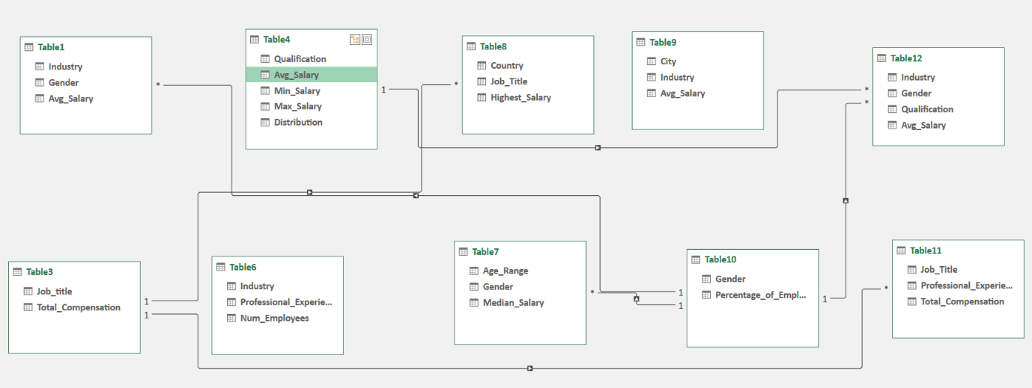

**Step5:PIVOT CHARTS AND TABLE**

* + Create Pivot table
  + Generated reports and dashboards using Excel
  + Compared salaries of man, Non-binary and Women.

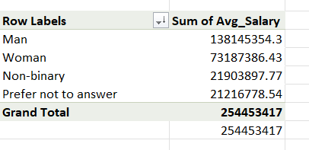

**Step6: Results Visualization & Interpretation**

* Generated reports and dashboards using Excel, and SQL.
* Compared salaries of man, Non-binary and Women.

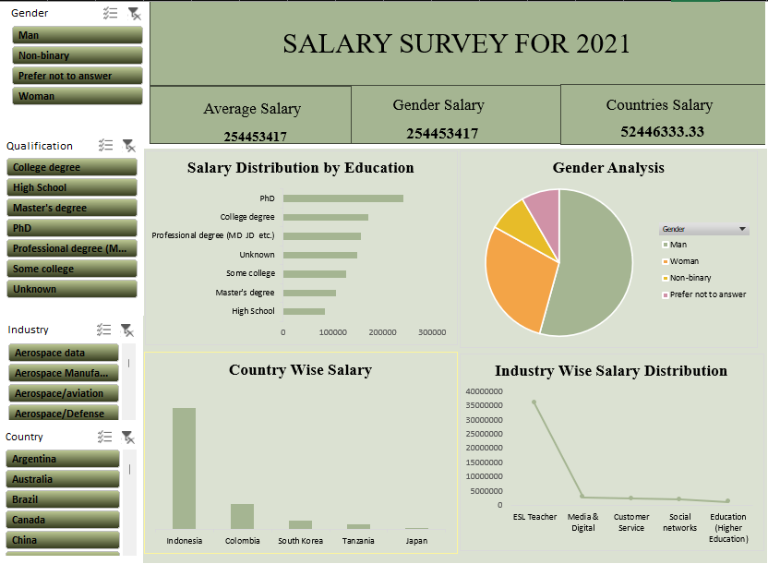**DASHBOARD:**

**Step7: Trends and Insights Extraction**

* Identified top-paying industries and job roles.
* Analysed salary differences based on experience and education level.

**INSIGHTS:**

**1.Regional Salary Variations**

* + Indonesia reports the highest average salaries among surveyed countries.
  + Tanzania has the lowest average salaries in the dataset.

**2.Impact of Education:**

* + Advanced degrees (Master’s, Ph.D.) correlated with higher salaries.
  + Certifications in computing, and Technology boosted pay.

**3.High-Demand Industries:**

* Computing, Technology, and Education sectors experienced the highest salary growth, driven by digital transformation and increased demand for specialized skills.

**4.Experience-based Salary Growth**

* Employees with more than 10 years of experience see exponential salary growth. Entry-level salaries vary widely depending on industry and location. Mid-career professionals (5-10 years of experience) see steady income progression.

**5.Gender-based Pay Gap**

* Male employees earn higher salaries on average than female employees.The gender pay gap is more significant in leadership and executive roles.Increased transparency in salary structures can help reduce inequalities.

**RECOMMENDATION:**

* Conduct Regular Pay Audits to ensure gender pay equity.
* Link Salary Increases to Education and Experience to reward growth.
* Ensure Salary Progression for All Roles to retain experienced talent
* Make Compensation More Transparent across job titles to avoid pay disparities.

**CONCLUSION:**

The Salary Survey 2021 analysis provides crucial insights into salary trends and disparities. It highlights key factors influencing compensation, including experience, industry, education, and location. The findings emphasize the importance of addressing gender pay gaps and regional inequalities to create a fairer job market.